**Gradient Boosting Theory**

Gradient Boosting is an ensemble learning technique used for both regression and classification tasks. It builds a model in a stage-wise manner, where each new model corrects the errors of the previous model.

**Key Concepts of Gradient Boosting**

1. **Boosting Concept:**
   * Boosting is an ensemble technique where multiple weak models (typically decision trees) are combined to form a strong predictive model.
   * Each subsequent model is trained to correct the residual errors made by the previous model.
   * The final model is a weighted sum of the weak models.
2. **Gradient Boosting Algorithm Steps:**
   * **Step 1: Initialize the Model:**  
     The initial prediction is typically the mean (for regression) or log-odds (for binary classification) of the target variable.
   * **Step 2: Compute the Residuals:**  
     Residuals are the differences between actual values and predicted values.
   * **Step 3: Fit a New Model:**  
     A new model (often a small decision tree) is trained on the residuals.
   * **Step 4: Update the Model:**  
     The new model’s predictions are added to the existing predictions with a weighting determined by the learning rate (Eta).
   * **Step 5: Repeat:**  
     Repeat steps 2 to 4 for a predefined number of models or until improvement slows.

**Key Features of Gradient Boosting**

* **Additive Nature:** Built sequentially, each tree corrects the errors of the previous one.
* **Gradient Descent:** Uses gradient descent to minimize a loss function (like mean squared error for regression or log loss for classification).
* **Regularization:** Techniques like Alpha (L1 Penalty) and Lambda (L2 Penalty) help prevent overfitting.

**Loss Functions**

* **For Regression:**
  + Mean Squared Error (MSE)
  + Mean Absolute Error (MAE)
* **For Classification:**
  + Log Loss (Cross-Entropy) for binary classification
  + Categorical Cross-Entropy for multi-class classification

**Advantages of Gradient Boosting**

* **High Predictive Power:** Often outperforms other algorithms such as random forests or logistic regression.
* **Flexible:** Can be applied to both regression and classification tasks.
* **Feature Importance:** Can naturally rank features by their importance in prediction.
* **Handles Complex Data:** Performs well with structured and unstructured data.

**Disadvantages of Gradient Boosting**

* **Slow Training:** Can be computationally expensive, especially with a large number of trees.
* **Overfitting:** Prone to overfitting without careful regularization and hyperparameter tuning.
* **Difficult to Parallelize:** Sequential nature makes parallelization challenging.

**Hyperparameters in Gradient Boosting**

The performance of a gradient boosting model is highly sensitive to the hyperparameters. Here's a breakdown of the key hyperparameters:

* **Gamma:**  
  Minimum loss reduction required to make a split in a tree. Controls tree pruning.  
  Range: 0 to 10.  
  Higher values prevent the tree from growing too large.
* **Alpha (L1 Penalty):**  
  Regularization parameter for feature selection using the L1 penalty.  
  Range: 0 to 1 (adjustable).  
  A higher Alpha reduces the number of features selected, preventing overfitting.
* **Lambda (L2 Penalty):**  
  Regularization parameter for L2 penalty (similar to Ridge regression).  
  Range: 0 to 10.  
  A higher Lambda regularizes the model, reducing overfitting.
* **Eta (Learning Rate):**  
  Controls the contribution of each tree to the final prediction. Optimal learning rate is often 0.1.  
  Range: 0.01 to 0.3 (typically 0.05, but 0.1 is considered optimal in many cases).  
  A smaller learning rate requires more trees and improves generalization.

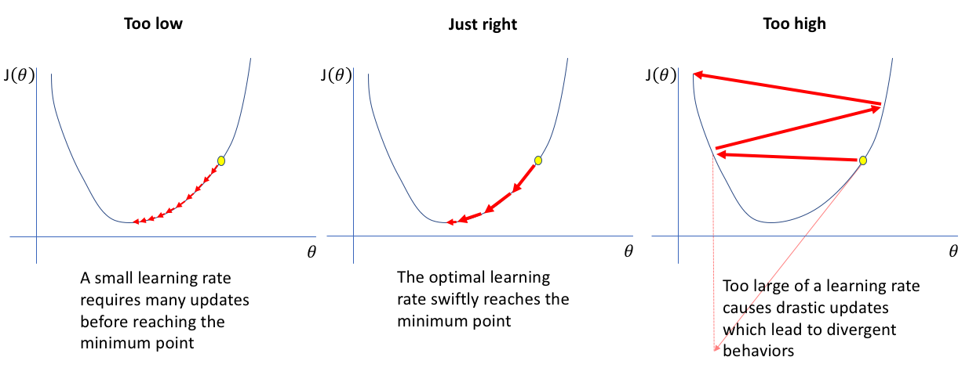

* **n_estimators:**  
  Number of trees in the model.  
  Range: 50 to 1000.  
  More trees increase model accuracy but also increase training time and risk of overfitting.

**Gradient Boosting vs. Other Ensemble Methods**

|  |  |  |  |  |
| --- | --- | --- | --- | --- |
| **Method** | **Parallelization** | **Sequential Process** | **Overfitting Risk** | **Typical Use Case** |
| **Gradient Boosting** | Low | Yes | High (if not tuned) | High accuracy in structured data, but sensitive to noise |
| **Random Forest** | High | No | Low | Handles noisy and unstructured data well |
| **AdaBoost** | Medium | Yes | High | Best for small datasets with weak classifiers |

**Visual Explanation of Gradient Boosting**

1. **Sequential Tree Building:**  
   Each new tree tries to correct the errors made by the previous tree.

scss

CopyEdit

Initial Prediction → Residuals (errors) → New Tree (fitting residuals) → Updated Prediction

1. **Example of Tree Correction Process:**  
   (Image placeholder for the tree correction process in gradient boosting)
   * **Initial Model:** The first tree makes predictions.
   * **Residuals:** The residuals (errors) are calculated between actual and predicted values.
   * **New Tree:** A new tree is built to predict the residuals.
   * **Update Predictions:** The new tree’s predictions are added to the previous ones to refine the model.

**Loss Function Optimization via Gradient Descent**

Gradient boosting minimizes the following loss function using gradient descent:

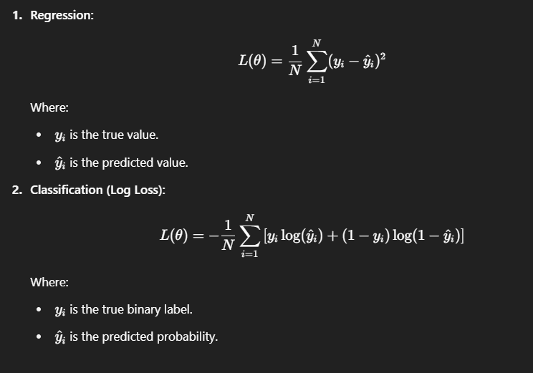

**Final Thoughts**

* **Gradient Boosting** is a highly effective and powerful algorithm, especially when tuned carefully.
* **Regularization** techniques like **Alpha** (L1 Penalty) and **Lambda** (L2 Penalty) help prevent overfitting and ensure that the model generalizes well.
* Understanding the **learning rate (Eta)** and the **number of trees (n_estimators)** is crucial for balancing model performance and computational efficiency.
* **Optimal Learning Rate:** While the default value for **Eta** is typically set between 0.01 to 0.3, **0.1** is often considered the optimal learning rate for many datasets and ensures a good balance between training speed and accuracy.